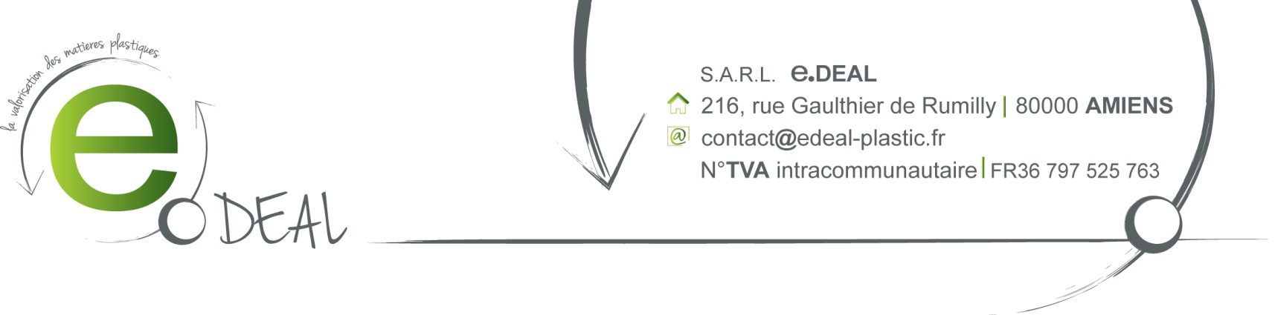

SALE CONFIRMATION

FUKUTOMI Co Ltd
Room 3202, 32/F – Asia Trade Centre
70 Lei Muk Road, Kwai Chung, N.T.
HONG KONG - CHINE

Contact : Peggy Cheung
File reference: JPC/050414 The 11st April 2014

F.O.B MONTOIR

Payment term: Receipt of invoice

Best Regards,



