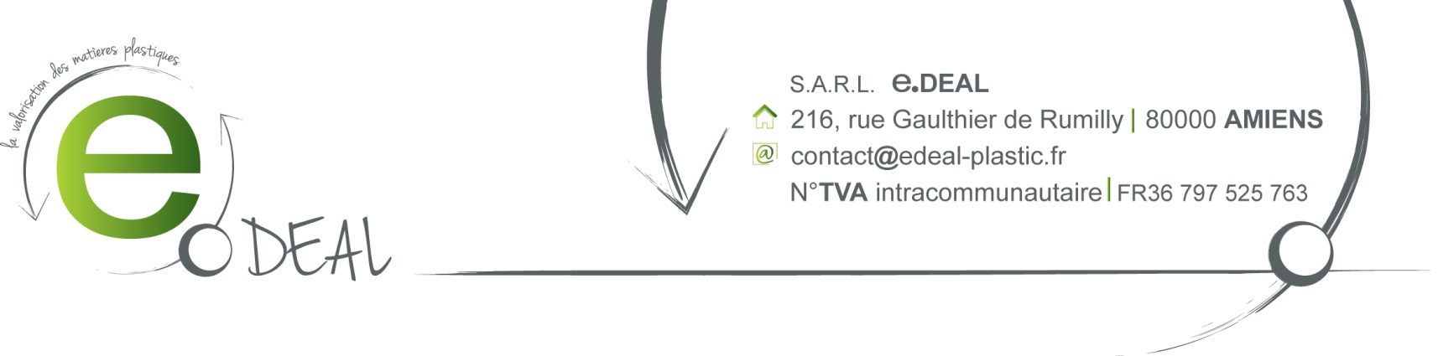

SALE CONFIRMATION

FUKUTOMI Ltd
Contact: - Peggy Cheung
File reference: SL150317 March the 24th 2015

F.O.B BASSENS

Payment term: Receipt of invoice

Best Regards,

