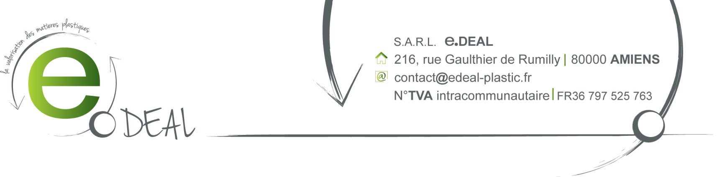

SALE CONFIRMATION

Contact: Peggy Cheung
File reference: JPC150302 February the 20th, 2014

F.O.B Le Havre

Payment term: Receipt of invoice

Best Regards,

