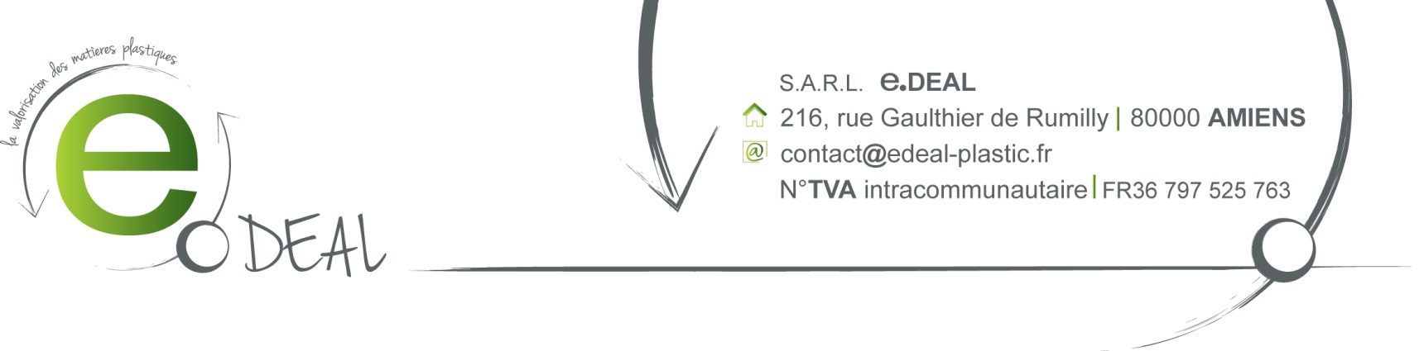

SALE CONFIRMATION

Contact: Peggy Cheung
File reference: JPC150306 March, the 5th 2015

F.O.B Le Havre

Payment term: Receipt of invoice

Best Regards,

